|  |  |
| --- | --- |
| **Practicum Case** |  |
| COMP6048 | COMP6048001 | COMP6048016 | COMP6048049  Data Structures |
| **Computer Science** | **O221-COMP6048-AM01-08** |
| ***Valid on*** *Even Semester Year 2021/2022* | **Revision 00** |

**Learning Outcomes**

* LO1 – Explain the concept of data structures and its usage in computer science
* LO2 – Illustrate any learned data structures and its usage in application
* LO3 – Apply data structures using C

## Topic

* Session 8 – AVL Tree

## Sub Topics

* Push
* Update
* Search
* Pop
* Pop All

## Soal

*Case*

**Bluejack GShop**

**Bluejak GShop** is one of the most popular offline game stores in town. Recently they want to open a new branch in another city. They need a programmer to help them create a program that can help them manage game stock in their warehouse. The criteria of the program are:

* The program consists of **4 menus**, there are:

1. **Insert Game**
2. **View Game**
3. **Update Stock**
4. **Exit**

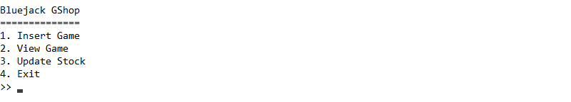

Figure . Main Menu

* If the user chooses **Insert Game** (**Menu 1**), then:
* Ask user to input the following data:
* **Game Title**
  + Validate the inputted game title must be **between 5 and 25 characters**.
  + Validate the inputted game title must be **unique**.
* **Game Genre**
  + Validate the inputted game genre must be **either** “**Action**”, “**RPG**”, “**Adventure**”, or “**Card Game**”.
* **Game Stock**
  + Validate the inputted game stock must be **at least 1**.
* Then, push the data to the **AVL Tree** with **game title** as **key**.

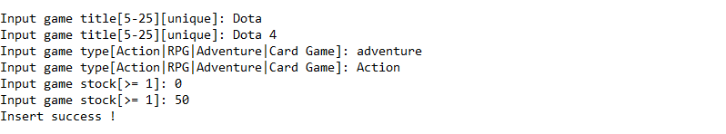

Figure . Insert Menu

* If the user chooses **View Game** (**Menu 2**), then:
* Validate if the data is **empty**, then show “**Warehouse is empty !**” message.



Figure . Data Empty Message

* **Otherwise**, **show all the game** using **In-Order method**.



Figure . Show Game Data Using In-Order Method

* If user chooses **Update Stock** (**Menu 3**), then:
* Ask user to input **game title**. Validate the inputted game title must **exist** in the **AVL Tree**. **Otherwise**, **show** “**Data not found**” **message** and **redirect back** to main menu.

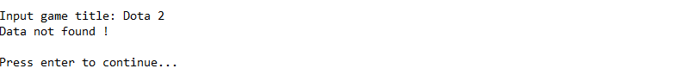

Figure . Data Not Found Message

* Then, ask user to input **update** **type**. Validate the inputted type must be **either** “**add**” or “**remove**” (**case insensitive**).
* After that, ask user to input the **quantity** to add or remove. If user **chooses** “**remove**”, validate the inputted quantity must be **between** **1 and** **current stock**. If user **chooses** “**add**” validate the inputted quantity must be **at least 1**.
* **Remove** or **add** the current stock with the inputted **quantity**. If user **remove all the remaining stock**, then **delete the data** from **AVL Tree**.

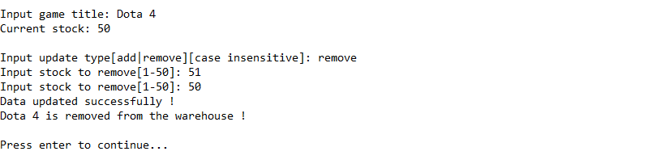

Figure . Data Removed Due To Out Of Stock

* If user chooses **Exit** (**Menu 4**), **terminate** the program.

**Please run the EXE file to see the sample program**